**Experiment-5**

**Name:** Dishant Modh

**Roll No.:** IT076

# Aim: Write a C/C++/Java program to generate and exchange public keys using client server mechanism.

# Code:

**Program1: Server Side**

import java.net.*;

import java.io.*;

import java.util.*;

public class Server {

public static void main(String[] args) throws IOException

{

try {

int port = 8088;

Scanner sc = new Scanner(System.in);

// Server Key

System.out.println("Enter the value of server key:- ");

int b = sc.nextInt();

// Client p, g, and key

double clientP, clientG, clientA, B, Bdash;

String Bstr;

// Established the Connection

ServerSocket serverSocket = new ServerSocket(port);

System.out.println("Waiting for client on port " + serverSocket.getLocalPort() + "...");

Socket server = serverSocket.accept();

System.out.println("Just connected to " + server.getRemoteSocketAddress());

// Server's Private Key

System.out.println("From Server : Private Key = " + b);

// Accepts the data from client

DataInputStream in = new DataInputStream(server.getInputStream());

clientP = Integer.parseInt(in.readUTF()); // to accept p

System.out.println("From Client : P = " + clientP);

clientG = Integer.parseInt(in.readUTF()); // to accept g

System.out.println("From Client : G = " + clientG);

clientA = Double.parseDouble(in.readUTF()); // to accept A

System.out.println("From Client : Public Key = " + clientA);

B = ((Math.pow(clientG, b)) % clientP); // calculation of B

Bstr = Double.toString(B);

// Sends data to client

// Value of B

OutputStream outToclient = server.getOutputStream();

DataOutputStream out = new DataOutputStream(outToclient);

out.writeUTF(Bstr); // Sending B

Bdash = ((Math.pow(clientA, b)) % clientP); // calculation of Bdash

System.out.println("Secret Key to perform Symmetric Encryption = "

+ Bdash);

server.close();

}

catch (SocketTimeoutException s) {

System.out.println("Socket timed out!");

}

catch (IOException e) {

}

}

}

**Program2: Client Side**

import java.net.*;

import java.io.*;

import java.util.*;

public class Client {

public static void main(String[] args)

{

try {

String pstr, gstr, Astr;

String serverName = "localhost";

int port = 8088;

Scanner sc = new Scanner(System.in);

// Declare p, g, and Key of client

System.out.println("Enter the value of p:- ");

int p = sc.nextInt();

System.out.println("Enter the value of g:- ");

int g = sc.nextInt();

System.out.println("Enter the value of client key:- ");

int a = sc.nextInt();

double Adash, serverB;

// Established the connection

System.out.println("Connecting to " + serverName

+ " on port " + port);

Socket client = new Socket(serverName, port);

System.out.println("Just connected to "

+ client.getRemoteSocketAddress());

// Sends the data to client

OutputStream outToServer = client.getOutputStream();

DataOutputStream out = new DataOutputStream(outToServer);

pstr = Integer.toString(p);

out.writeUTF(pstr); // Sending p

gstr = Integer.toString(g);

out.writeUTF(gstr); // Sending g

double A = ((Math.pow(g, a)) % p); // calculation of A

Astr = Double.toString(A);

out.writeUTF(Astr); // Sending A

// Client's Private Key

System.out.println("From Client : Private Key = " + a);

// Accepts the data

DataInputStream in = new DataInputStream(client.getInputStream());

serverB = Double.parseDouble(in.readUTF());

System.out.println("From Server : Public Key = " + serverB);

Adash = ((Math.pow(serverB, a)) % p); // calculation of Adash

System.out.println("Secret Key to perform Symmetric Encryption = "

+ Adash);

client.close();

}

catch (Exception e) {

e.printStackTrace();

}

}

}

**Output:**

**Server Side:**

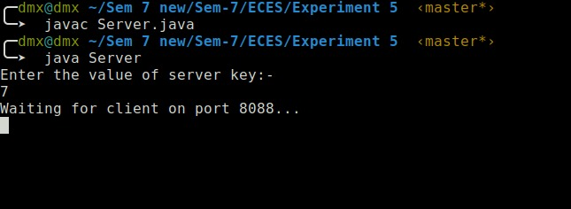

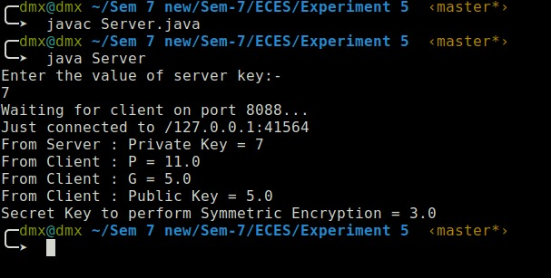

**Client Side:**

